
COURSE: BACHELOR OF SCIENCE IN INFORMATION TECHNOLOGY
DEPARTMENT: COMPUTING AND INFORMATICS
LECTURER : MICHAEL NYORO
ADM NO:BSCCS/2024/54233
NAME:SALAH HUSSEIN SALAH
COURSE: BACHELOR OF SCIENCE IN INFORMATION TECHNOLOGY
UNIT CODE:BIT4138
UNIT NAME:ADVANCED CRYPTOGRAPHY
PROJECT DETAILS
SECURE FILE ENCRYPTION SYSTEM
SELECTED TECHNOLOGIES:
Python 3
Python Cryptography Library
OpenSSL
DEVELOMENT TOOLS:
VS Code
IMPORTANCE
This project demonstrates practical implementation of cryptographic techniques including classical and modern encryption algorithms. It promotes secure coding practices, version control using Git, and strengthens understanding of data protection, encryption workflows, and cybersecurity development practices.

ONLINE PORTFOLIO
https://github.com/slxxssn/Advanced-Cryptography-Project.git

Contents
WEEK 1:Cryptography Environment SetUP 4
Python and VS Code installation 4
Fig 1.) Installation of Python and VS Code 4
Cryptography Library Installation 4
Fig 2.)Installation of Cryptography Libraries 5
Open SSL Installation test 5
Fig 3.)OpenSSL Installation Test 5
Local Encryption Script Execution 6
Fig 4.)Local Encryption Script Exection 6
GitHub Repository Initialization 6
Fig 5.)GitHub Repository Initialization 7
Student Reflection 7
Week 1 Summary 7
WEEK 2:Classical Cryptography and Cipher Design 8
Caeser Cipher Implementation 8
Fig 6.) shows Caeser Cipher Implementation 8
Vigenere Cipher Encryption Process 8
Fig 7.) shows Vigenere Cypher Encryp Process 8
Encryption and Decryption Output 9
Fig 8.) shows Encryption and Descryption Output 9
User Input Validation Interface 9
Fig 9.) shows User Validation Input 10
Cipher Testing Results 10
Fig 10.) shows Cipher Testing Results 10
Student Reflection 11
Week 2 Summary 11
Week 3:Stream Ciphers and Randomness Testing 11
LSFR Generator Implementation 11
Fig 11.) shows LSFR Generator 11
Pseudorandonmness Sequence Output 12
Fig 12.) shows Pseudorandomness Sequence Output 12
Statistical Random Testing 12
Fig 13.)Statistical Random Testin 12
RC4 Stream Cipher Simulation 13
Fig14.) shows RC4 Stream Cipher Simulation 13
Encryption Performance Results 13
Fig 15.) shows Encryption Performance Results 13
Student Reflection 14
Week 3 Summary 14
WEEK 4:Block Cipher Design and AES 15
AES Encryption Script 15
Fig 16.) shows Aes Encryption Script 15
Key Generation Process 16
Fig 17.) shows Key Generation Process 16
File Encryption Demonstration 16
Fig 18.) shows File Encryption Demonstration 16
Decryption Results 16
Fig 19.) shows Decryption Results 16
AES Performance Testing 17
Fig 20.) shows AES Performance Testing 17
Student Reflection 17
Week 4 Summary 17
WEEK 5:Public Key Cryptography 18
RSA Key Pair Generation 18
Fig 21.) shows RSA Key Pair Generation 18
Public Key Encryption Process 18
Fig22.) shows Public Key Encryption Process 18
Private Key Decryption Results 19
Fig 23.) shows Private Key Decryption Results 19
Secure Message Transmission 19
Fig 24.) shows Secure Message Transmission 19
RSA Testing and Validation 20
Fig 25.) shows RSA Testing and Vallidation 20
Student Reflection 21
Week 5 Summary 21

WEEK 1:Cryptography Environment SetUP

Python and VS Code installation

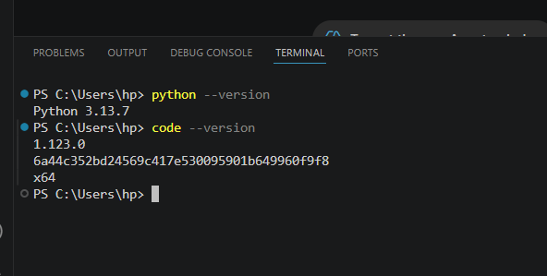

Fig 1.) Installation of Python and VS Code
This confirms successful installation of Python and Visual Studio Code, providing the core development environment required for implementing cryptographic algorithms and secure coding practices in subsequent tasks.

Cryptography Library Installation
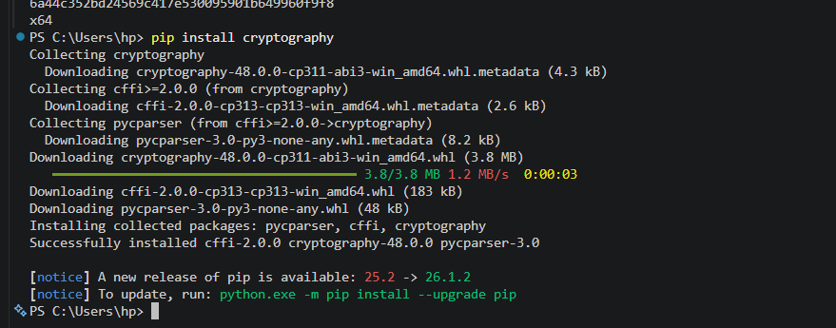

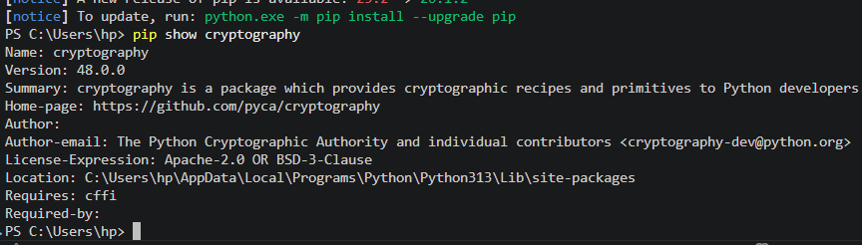

Fig 2.)Installation of Cryptography Libraries
This demonstrates successful installation of the Python cryptography library, which provides secure implementations of encryption algorithms used for developing modern cryptographic systems.

Open SSL Installation test
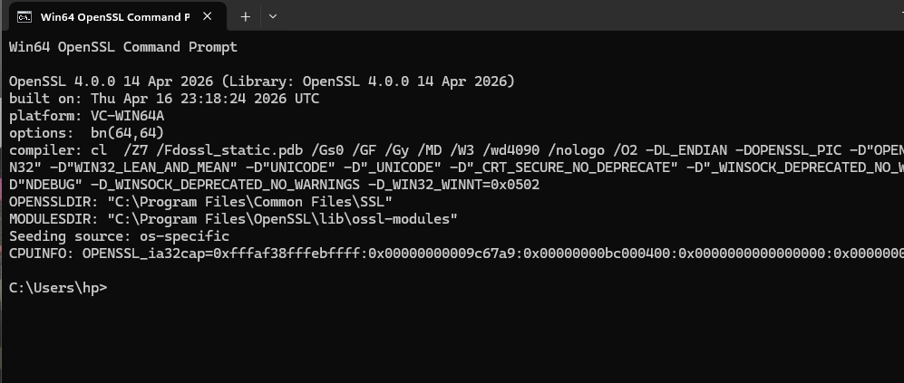

Fig 3.)OpenSSL Installation Test
This confirms successful installation and configuration of OpenSSL used for generating secure cryptographic keys and certificates, which are essential in public key infrastructure systems.

Local Encryption Script Execution

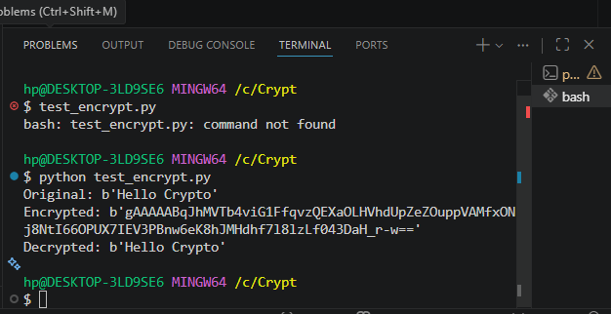

Fig 4.)Local Encryption Script Exection
This illustrates execution of a local encryption script using the Fernet symmetric encryption method, demonstrating successful encryption and decryption of data within a controlled environment.

GitHub Repository Initialization

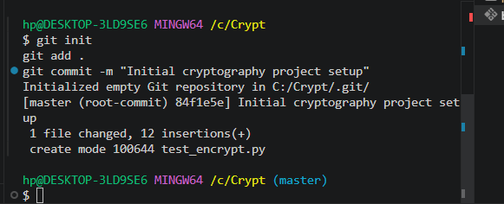

Fig 5.)GitHub Repository Initialization
This shows initialization of a GitHub repository and first commit, demonstrating version control setup and secure software development workflow for tracking cryptographic project progress.

Student Reflection
This week I configured a cryptography development environment using Python, VS Code, OpenSSL, and Git. I learned how encryption scripts execute and how version control tracks code changes. Challenges included terminal command issues and PATH configuration, which were resolved through systematic debugging and verification.

Week 1 Summary
This week focused on setting up a secure cryptography development environment. Tools including Python, OpenSSL, and Git were successfully installed and configured. A basic encryption script was executed, and version control was initialized to support structured development of cryptographic algorithms in upcoming weeks.

WEEK 2:Classical Cryptography and Cipher Design

Caeser Cipher Implementation
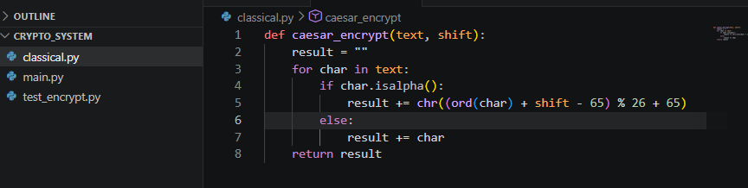

Fig 6.) shows Caeser Cipher Implementation
This shows the implementation of the Caesar Cipher algorithm, where each character is shifted by a fixed key value to achieve substitution-based encryption within the classical cryptography module

Vigenere Cipher Encryption Process
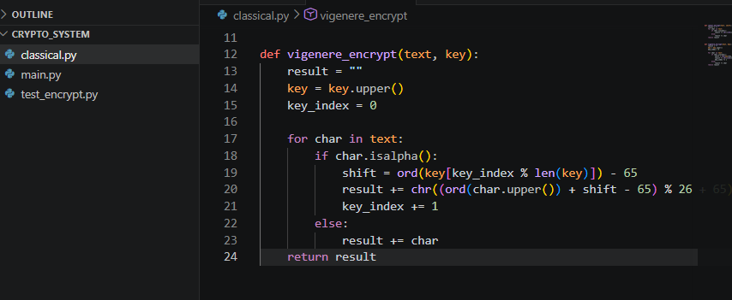

Fig 7.) shows Vigenere Cypher Encryp Process
This demonstrates the Vigenère Cipher encryption process, which uses a keyword-based polyalphabetic substitution method to enhance security compared to simple Caesar Cipher encryption

Encryption and Decryption Output
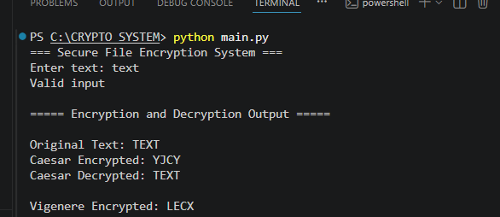

Fig 8.) shows Encryption and Descryption Output
This shows successful encryption outputs using both Caesar and Vigenère algorithms, demonstrating correct transformation of plaintext into ciphertext using different key mechanisms.

User Input Validation Interface
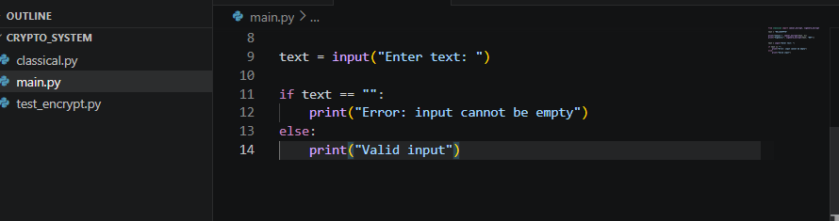

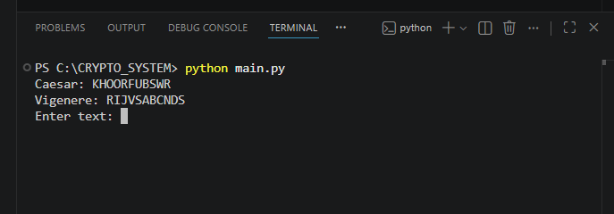

Fig 9.) shows User Validation Input
This demonstrates user input validation ensuring that the system only processes valid non-empty inputs before encryption is performed.

Cipher Testing Results

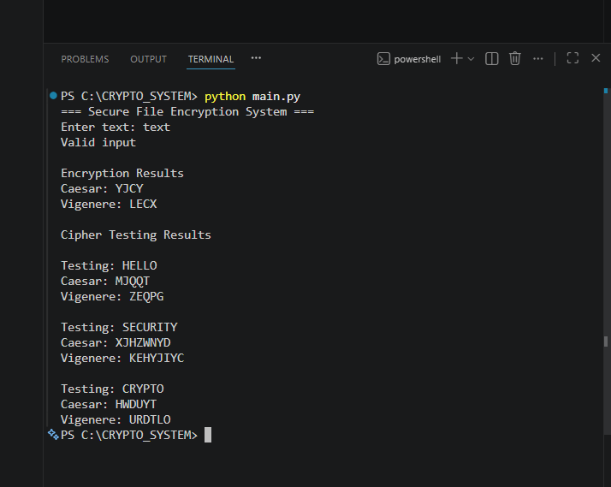

Fig 10.) shows Cipher Testing Results
This shows testing of classical cipher algorithms using different keys, verifying correctness and consistency of encryption outputs across multiple test cases.

Student Reflection
Classical encryption algorithms such as Caesar and Vigenère were implemented to demonstrate substitution-based cryptography. The importance of encryption keys in securing data was observed, along with the workflow of transforming plaintext to ciphertext. Weaknesses include susceptibility to brute-force and frequency analysis attacks.

Week 2 Summary
This week focused on implementing classical cryptographic algorithms within the Secure File Encryption System. Caesar and Vigenère ciphers were developed and tested successfully. User input validation and encryption output verification were performed, demonstrating foundational encryption principles and highlighting limitations of classical cryptog

Week 3:Stream Ciphers and Randomness Testing

LSFR Generator Implementation

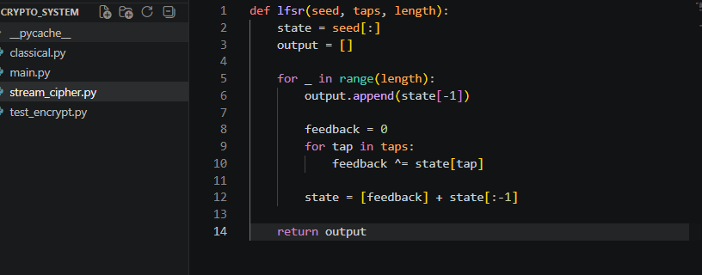

Fig 11.) shows LSFR Generator
This shows implementation of a Linear Feedback Shift Register (LFSR) used to generate pseudorandom binary sequences for stream cipher operations within the Secure File Encryption System.

Pseudorandonmness Sequence Output
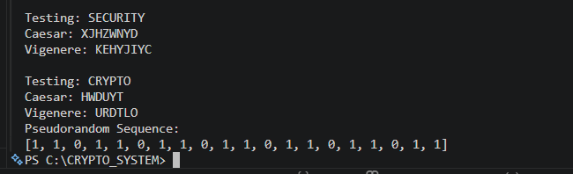

Fig 12.) shows Pseudorandomness Sequence Output
This demonstrates successful generation of a pseudorandom binary sequence using the LFSR generator, providing a keystream source for stream cipher simulations.

Statistical Random Testing

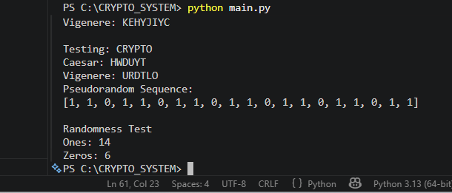

Fig 13.)Statistical Random Testin
This presents statistical analysis of the generated pseudorandom sequence by comparing the distribution of ones and zeros to evaluate randomness quality.

RC4 Stream Cipher Simulation
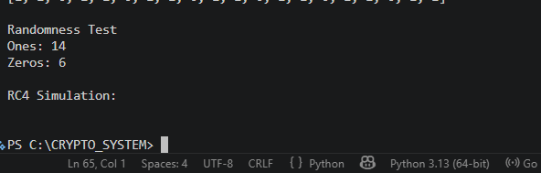

Fig14.) shows RC4 Stream Cipher Simulation
This demonstrates stream cipher encryption using an RC4-style XOR operation where plaintext characters are encrypted using a repeating keystream.

Encryption Performance Results

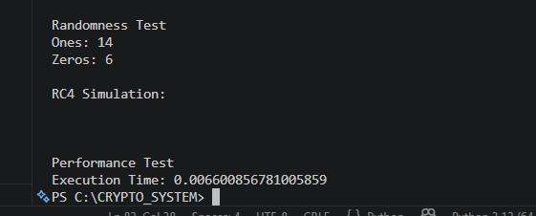

Fig 15.) shows Encryption Performance Results
Fig 5 presents performance testing results measuring stream cipher execution speed, demonstrating the efficiency of stream-based encryption operations.

Student Reflection
Implementation of LFSR and RC4 stream cipher concepts demonstrated the importance of pseudorandom sequence generation in cryptography. Randomness testing was performed to evaluate keystream quality. The exercises showed how stream ciphers encrypt data efficiently while highlighting the need for secure random number generation.

Week 3 Summary
This week focused on stream cipher implementation and randomness analysis within the Secure File Encryption System. LFSR-generated sequences, statistical testing, RC4 simulation, and performance evaluation were successfully implemented, strengthening understanding of keystream generation and efficient encryption techniques.

WEEK 4:Block Cipher Design and AES

AES Encryption Script

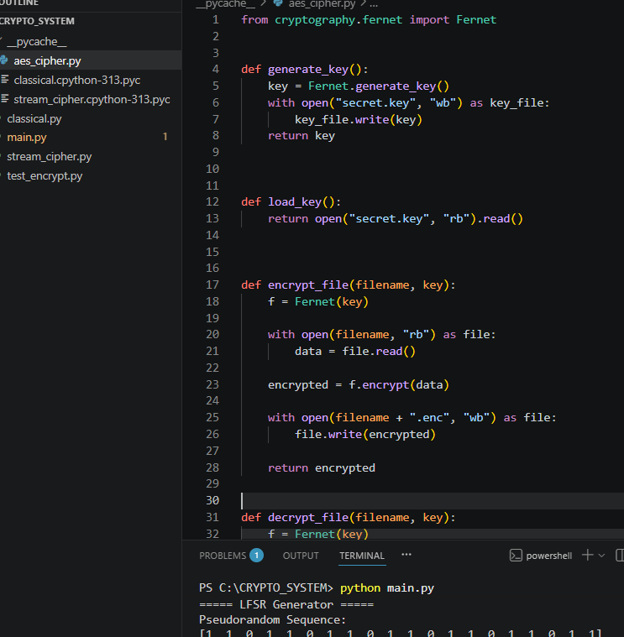

Fig 16.) shows Aes Encryption Script

Key Generation Process

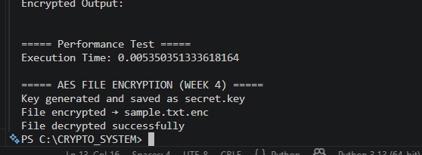

Fig 17.) shows Key Generation Process

File Encryption Demonstration
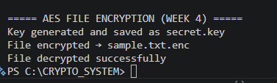

Fig 18.) shows File Encryption Demonstration

Decryption Results
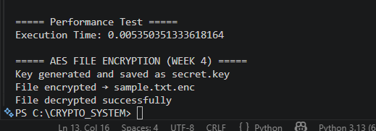

Fig 19.) shows Decryption Results

AES Performance Testing
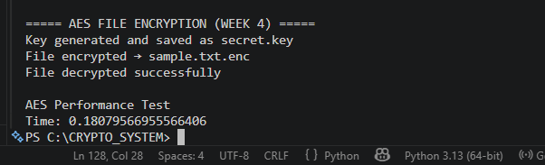

Fig 20.) shows AES Performance Testing

Student Reflection
AES encryption was implemented to secure file data using symmetric key cryptography. The workflow involved key generation, file encryption, and decryption processes. Key security was essential to ensure confidentiality. Challenges included handling file I/O operations and ensuring correct encryption-decryption mapping.

Week 4 Summary
This week focused on implementing AES-based file encryption within the Secure File Encryption System. The system successfully encrypted and decrypted files using symmetric keys. Key generation and performance testing were conducted, completing the transition from classical cryptography to modern secure file encryption.

WEEK 5:Public Key Cryptography

RSA Key Pair Generation
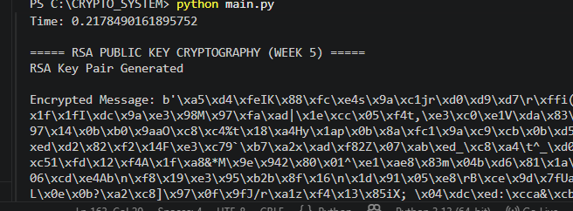

Fig 21.) shows RSA Key Pair Generation
This demonstrates successful generation of an RSA public and private key pair. The key pair forms the foundation of asymmetric cryptography, where the public key is used for encryption and the private key is used for decryption, ensuring secure communication.

Public Key Encryption Process
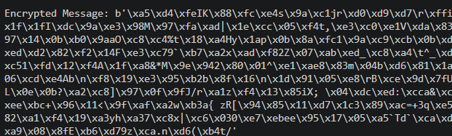

Fig22.) shows Public Key Encryption Process
This shows the encryption of a plaintext message using the RSA public key. The output ciphertext is unreadable, demonstrating how RSA protects sensitive information during transmission over insecure networks.

Private Key Decryption Results
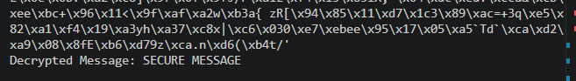

Fig 23.) shows Private Key Decryption Results
This confirms successful decryption of the encrypted message using the RSA private key. The recovered plaintext matches the original message, verifying the correctness of the RSA encryption and decryption process.

Secure Message Transmission
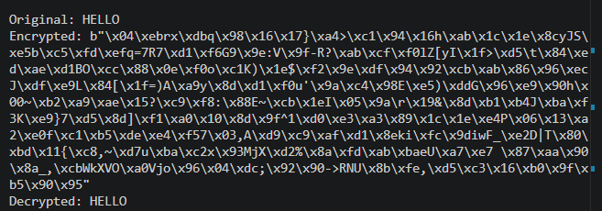

Fig 24.) shows Secure Message Transmission
This illustrates the complete RSA communication workflow where a message is encrypted with a public key and securely recovered using the corresponding private key. The process demonstrates confidentiality and secure data exchange.

RSA Testing and Validation
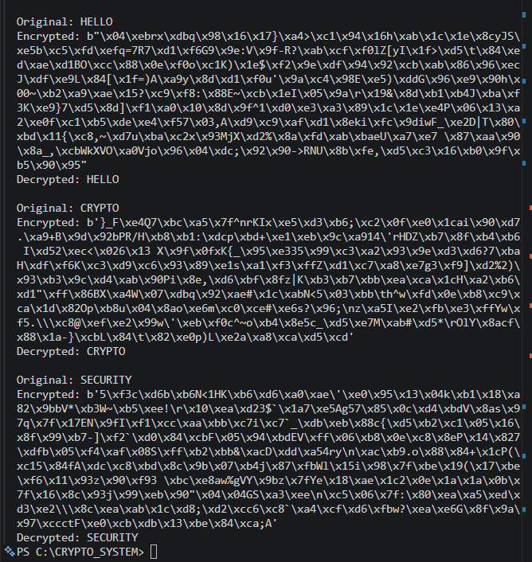

Fig 25.) shows RSA Testing and Vallidation
This presents the testing of RSA using multiple messages. Each message was encrypted and successfully decrypted, confirming the reliability, accuracy, and effectiveness of the RSA implementation under different test scenarios.

Student Reflection
RSA demonstrated asymmetric encryption using a public and private key pair. Public keys were used for encryption while private keys enabled secure decryption. This method ensures secure communication without sharing secret keys. Testing confirmed correct encryption-decryption workflow and strong security advantages over symmetric systems.

Week 5 Summary
This week implemented RSA public key cryptography within the Secure File Encryption System. Key generation, encryption, and decryption processes were successfully demonstrated. The system highlighted secure communication using asymmetric keys and validated message integrity through testing, completing the transition from classical to modern cryptographic techniques..

